Technical Report AFOBMCIS 2026 Title
(Times New Roman, 12 font size, Bold, Centered)
First Author’s Full Name¹, Second Author’s Full Name^{2*} and Third Author’s Full Name³
(Times New Roman, 12 font size, Bold, Centered)
^{1, 2}Organization information that the author is committed to
³Organization information that the author is committed to
*E-mail: correspondingauthorsname@aaaa.bbb

Abstract (Times New Roman, 12, bold, 150 words) This template explains and demonstrates how to prepare your technical report 2026. The best is to read these instructions and follow the outline of this text. Page margins are formed regarding the A4 page size and are 2.54 cm wide from the right, left, top and bottom. We therefore ask that authors follow some simple guidelines. In essence, you should format your paper exactly like this document.
Keywords: Abstract, introduction, material and methods, results and discussion (maximum 5 keywords)

Introduction
The full paper should be written in MS Word format, preferably as .doc file. Use 1.5 lines-spacing in 12 font size Times New Roman. Please indent the text paragraphs. Please state clearly the aim (and scope) of the study, the materials and methods, the main findings and brief analysis of the study. Extended abstracts can contain figures, tables, formulations or images. Technical report should be at least 3 pages and not exceed five (5) pages including the references and pages should not be numbered.
All references should be cited in the text following APA in text citation by square brackets (Author 1, year). Two or more references at a time may be put in one set of brackets (Author 1 & Author 2, Year) [Three or More Authors] (Author 1 et al., year) or Author 1 (year); Author 1 & Author 2 (Year); Author 1 et al. (year). References should be listed alphabetically at the end of the document under the heading "References." Each reference entry should include the author's name, publication year, title of the work, and source details.

Materials and Methods
All materials and methods that have been used in the work must be stated clearly and subtitles should be used when necessary.

Subtitle
Second level headings are typed in Times New Roman, 12 font size, italic and bold with capital first letters.

Results and Discussion
Subtitle
All of the tables, images and figures should be centred. Figures and images should be numbered together (Figure 1) and figure definitions should be placed under the figure or image; as for the tables, they should also be numbered (Table 1) and the table header should be placed at the top of the chart. Table, image and figure headers should be written with upper case initial letters, bold and should be centred.
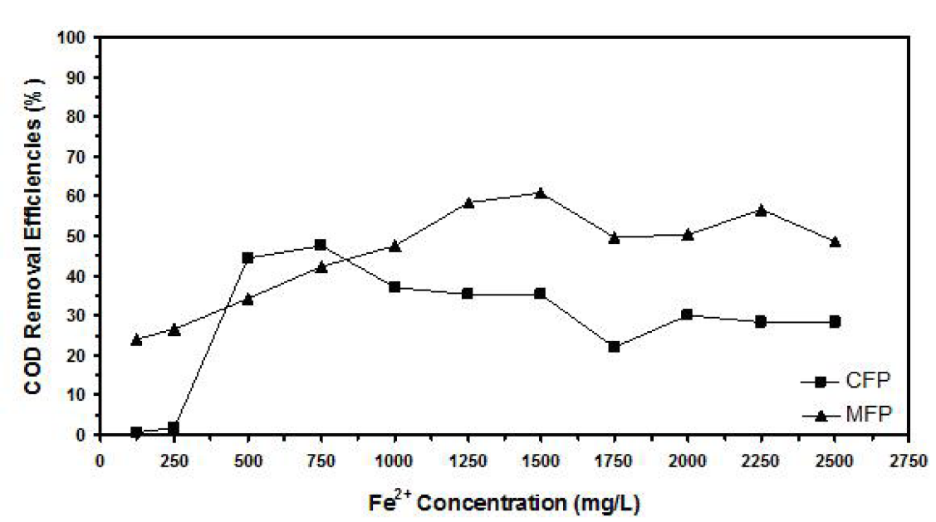
Figure 1. Example of figure for the full paper.

Subtitle
A table should be inserted like the one below and referred in the text as Table 1, Table 2, and so on. Please avoid vertical rules and shading in table cells.

Table 1. Example of table for the extended abstract
Symbol | Value
A
B

Equations
Equations (refer with: (1), (2), ...) should be indented. It is recommended to have one line of space above the equation and one line of space below it before the text continues. The equations have to be numbered sequentially, and the number put in parentheses at the right-hand edge of the text. Equations should be punctuated as if they were an ordinary part of the text. Punctuation appears after the equation but before the equation number, e.g.

c² = a² + b² | (1)

Conclusion
Please conclude your work incorporating your most important finding as well as future works (3-4 lines).

REFERENCES (APA Style)
1. Author, A. A. (Year). Title. Journal, Volume(Issue), Pages. (Journal Article)
2. Author, A. A. (Year).Title. Paper presented at the Conference Name, Date, Conference Location. Place Published: Publisher. (Conference Papers)
3. Author, A. A. (Year).Title. In Proceedings of the Conference Name, Year of Conference Date, Conference Location (pp. Pages). Place Published: Publisher. (Conference Proceedings)
4. Author, A. A. (Year). Title (Edition ed.). Place Published: Publisher. (Book)
5. Author, A. A. (Year). Title. In Editor’s name (Ed.), Book Title (Volume, Edition ed., pp. Pages). Place Published: Publisher. (Book Section)
6. Author, A. A. (Year). Title [Thesis Type, University]. Place Published: University. (Thesis)

